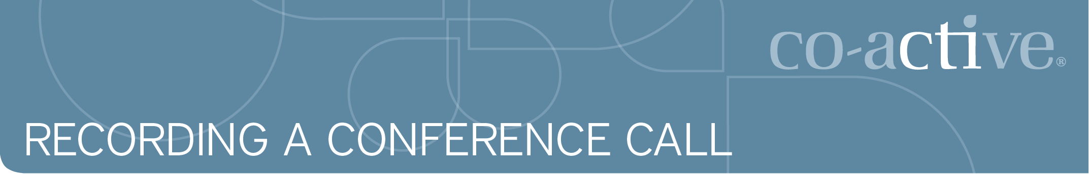
Recording a Conference Call Using Audio Acrobat

Bridgeline Recording Procedure
Before you begin recording the conference call, it’s a good idea to do a system check:
- If using headsets, test your voice level to record at the proper volume.
- Make sure you are using a landline for the best results. Avoid using a cell or a cordless/wireless phone. Cordless phones, cell phones and Voice Over IP (VoIP) connections can be troublesome.
- To record using Audio Acrobat, you must have three-way calling one line for you, one for your participant(s) and one for Audio Acrobat.

Connect Audio Acrobat to Record a Call
- Call the bridgeline and connect with your conference call audience.
- Once you confirm all callers are on the line make your connection to Audio Acrobat. Inform your conference call audience that you will be recording the call and will return in 15-20 seconds.
- To start the recording, Flash or Conference to access a third line.
- Dial the Audio Acrobat Direct Dial phone number: (201) 283-9143
- When prompted, enter the PIN: 106-464-437#.
- Important: If you get a busy signal or a message that your PIN is invalid, that typically implies an issue with the connection. Call the backup telephone number (512) 827-0500 and use the same PIN number 106-464-437#.
- After you enter the PIN, you will hear the phone prompt. To start the conference call recording, press 3 on your phone keypad.
- After pressing 3, you will hear a prompt.
- As soon as you hear the prompt say "Patch this line into your conference call now," press the Flash or Conference button to return to your conference call participants.
- You will hear two audible tones when the recording starts.
- To stop the recording process, press the Flash or Conference button again and Audio Acrobat will disengage. You can also hang-up the phone to disconnect. We recommended that you are the last to hang up if you are hosting the conference call.
- Email to audio@coactive.com per the instructions below.

Getting Your Audio Published
For all calls except exams, send an email to audio@coactive.com within 24 hours of the recording and include the following:
- Date, time, type and length of the call
- The title of the call
- Who led the call
- Where the call should be posted
- Who should have access to the call

